**Experiment -1**

**Aim** - Write HTML code to display the following output and also display title using heading tag.

**CPU**

**CPU** stands for the Central Processing Unit.

It is the portion of a computer system that carries

Out the instructions of a computer program.

It carries out each instruction of the program in sequence,

to perform the basic arithmetical, logical, and input/output operations of the system

**Code** -

<html>

<head>

<title>CUN1710991412</title>

</head>

<body>

<p> <h1><b> CPU </b></h1> </p>

<b> <u> CPU </b> stands for Central Processing Unit. </u>

<br>It is a portion of a <u> computer </u> system that carries

<br>out the instruction of a <u> computer </u> program.

<br>It carries out each instruction of the program in sequence

<br>to perform the basic arithmetical, logical and input/output operations of the system.

</body>

</html>

**Output** -

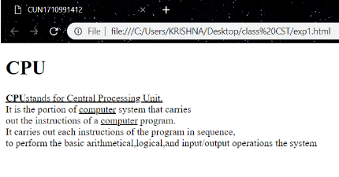

**Experiment - 2**

**Aim** - Write HTML code for the diagram using horizontal line, heading tag, colors to suitably distinguish headings, font styling like italics and underline as shown.



**Code** -

<html>

<head>

<title>CUN1710991412</title>

</head>

<body>

<h1 style="color: red">Bachelor of Engineering</h1>

<h2 style="color: pink">Bachelor of Engineering</h2>

<h3 style="color: yellow">Bachelor of Engineering</h3>

<h4 style="color:green">Bachelor of Engineering</h4>

<h5 style="color: blue">Bachelor of Engineering</h5>

<h6>Bachelor of Engineering</h6>

<h5 style="color: blue">Bachelor of Engineering</h5>

<h4 style="color: green">Bachelor of Engineering</h4>

<h3 style="color: yellow">Bachelor of Engineering</h3>

<h2 style="color: pink">Bachelor of Engineering</h2>

<h1 style="color: red">Bachelor of Engineering</h1>

</body>

</html>

**Output** -

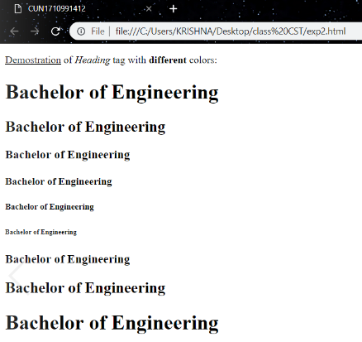

**Experiment - 3**

**Aim** - Demonstrate the usage of formatting, marquee and blink tag to print below output.

H2O

H2SO4

Text

X2

X2 + Y2=Z

Y = mx + c

**Code** -

<html>

<head>

<title>CUN1710991412</title>

</head>

<body>

H<sub>2</sub>O

<br>H<sub>2</sub>SO<sub>4</sub>

<br><strike>Text</strike>

<br>x<sup>2</sup>

<br>x<sup>2</sup> + y<sup>2</sup> = z

<br>y = mx + c

</body>

</html>

**Output** -

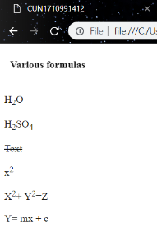

**Experiment - 4**

**Aim** - Write HTML code to display following list.

1. Linux
2. Unix
3. HTML
4. DHTML
5. JavaScript
6. Perl
7. PHP
8. SQL
9. Oracle

**Code** -

<html>

<head>

<title>CUN1710991412</title>

</head>

<body>

<ol>

<li>Linux</li>

<li>Unix</li>

<li>HTML</li>

<li>DHTML</li>

<li>JavaScript</li>

<li>Perl</li>

<li>PHP</li>

<li>SQL</li>

<li>Oracle</li>

<li>CCNA</li>

</ol>

</body>

</html>

**Output** -

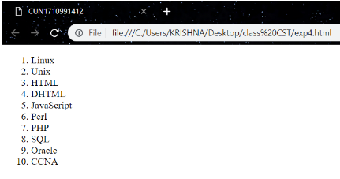

**Experiment - 5**

**Aim** - Write HTML code to display following list.

**Bachelor of Engineering**

* CSE
  + Software Engineering
  + Data Structures
  + Theory of Computation
* ME
  + Strength of Material
  + Mobility
* ECE
  + VLSI Design
  + Wireless Communication

**Code** -

<head>

<title>CUN1710991412</title>

</head>

<body>

<h1>Bachelor of Engineering </h1>

<ul>

<li type="circle">CSE</li>

<ul type="disc">

<li>Software Engineering</li>

<li>Data Structures</li>

<li>Theory of Computation</li>

</ul>

</ul>

<ul>

<li type="circle">ME</li>

<ul type="disc">

<li>Strength of Material</li>

<li>Mobility</li>

</ul>

</ul>

<ul>

<li type="circle">ECE</li>

<ul type="disc">

<li>VLSI Diagram</li>

<li>Wireless Communication</li>

</ul>

</ul>

</body>

</html>

**Output** -

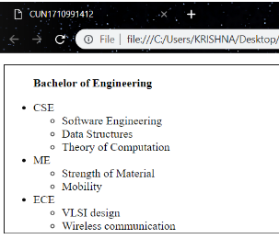

**Experiment - 6**

**Aim** - Write the HTML code to add a link on the text “Click here” and image of “Chitkara university logo”, when you click on these link then open[www.chitkara.edu.in](http://www.chitkara.edu.in).

**Code** -

<html>

<head>

<title>CUN1710991412</title>

</head>

<body>

<a href="<https://www.chitkara.edu.in>">

<img src="C:\Users\mukebaaj\Pictures\chitkara-dark-logo.jpg"></a>

<br><a href="https://www.chitkara.edu.in"><button>Click here</button></a>

</body>

</html>

**Output** -



**Experiment - 8**

**Aim** - Create an image-map, with clickable regions. Use image of India and create link for any 5 states.

**Code** -

<html>

<head>

<title>CUN1710991412</title>

</head>

<body>

<img src="D:\work\done\states.gif" usemap="#html">

<map name="html">

<area shape="poly" coords="138,158,154,142,151,125,165,117,172,118,192,148,182,160,166,166,156,161,138,158" href="http://punjabtourism.gov.in/">

<area shape="poly" coords="56,215,78,193,83,202,100,195,107,191,113,178,122,177,128,166,131,156,138,158,140,163,149,162,151,173,162,177,175,198,185,203,190,199,190,209,197,205,202,215,198,225,209,225,183,244,184,255,195,255,185,262,188,271,169,280,169,267,157,261,151,261,151,284,139,296,117,268,85,261,78,240,69,240,69,221,59,221,56,215" href="http://www.tourism.rajasthan.gov.in/">

<area shape="poly" coords="233,136,263,161,250,169,250,180,242,185,231,184,224,178,221,168,211,168,211,159,206,154,206,142,223,139,233,136" href="<http://uttarakhandtourism.gov.in/>">

<area shape="poly" coords="121,441,131,447,130,456,127,458,121,441" href="https://goa-tourism.com/">

<area shape="poly" coords="388,206,397,202,399,218,387,221,388,205" href="http://www.sikkimtourism.gov.in/Webforms/General/Default.aspx">

</body>

</html>

**Output** -

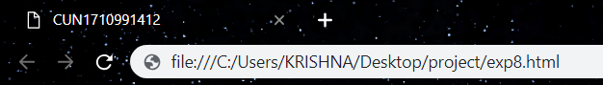

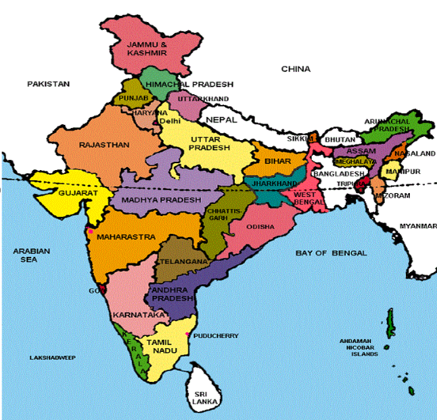

**Experiment - 9**

**Aim** - Write HTML code for the following table:

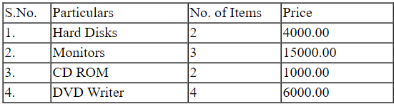

**Code** -

<html>

<head>

<title>CUN1710991412</title>

</head>

<body>

<table border="1" cellspacing="0">

<tr>

<td width="50">S.No.</td>

<td width="150">Particulars</td>

<td width="100">No. of Items</td>

<td width="120">Price</td>

</tr>

<tr>

<td>1. </td>

<td>Hard Disks</td>

<td>2</td>

<td>4000.00</td>

</tr>

<tr>

<td>2. </td>

<td>Monitors</td>

<td>3</td>

<td>15000.00</td>

</tr>

<tr>

<td>3. </td>

<td>CD ROM</td>

<td>2</td>

<td>1000.00</td>

<tr>

<td>4. </td>

<td>DVD Writer</td>

<td>4</td>

<td>6000.00</td>

</tr>

</table>

</body>

</html>

**Output** -

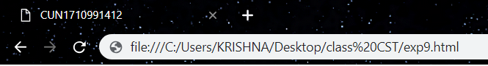

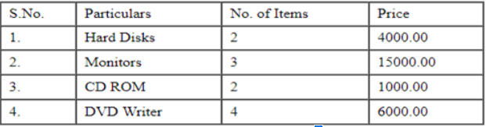

**Experiment - 10**

**Aim** - Create a table to show your class time-table.

**Code** -

<html>

<head>

<title>CUN1710991412</title>

</head>

<body>

<h1><center>CSE 4B</center></h1>

<span style="margin-left:230">Chitkara University, Jhansla, Distt. Patiala-140401, Punjab</span>

<center>

<table border="1" cellspacing="0" height="55" width="70%">

<tr>

<th></th>

<th>1<br><br><font size="1">9:00-9:55</font></th>

<th>2<br><br><font size="1">9:55-10:50</font></th>

<th>3<br><br><font size="1">10:50-11:45</font></th>

<th>4<br><br><font size="1">11:45-12:40</font></th>

<th>5<br><br><font size="1">12:40-1:35</font></th>

<th>6<br><br><font size="1">1:35-2:30</font></th>

<th>7<br><br><font size="1">2:30-3:25</font></th>

<th>8<br><br><font size="1">3:25-4:20</font></th>

</tr>

<tr>

<td width=75><center><font size="6">Mo</font></center></td>

<td colspan="2" style="background-image: linear-gradient(-200deg,green 50%,aqua 50%);"><br><br><center><font size="5">Core Java</font></center>

<p style="text-align: left"><font size="1">TG-508 Lab</font>

<span style="float: right"><font size="1">Anchal Kathuria</font></span></p>

</td>

<td bgcolor="darkgreen" colspan="2"><br><br><center><font size="5">DBMS-Lab</font></center>

<p style="text-align:left"><font size="1">TG-508 Lab</font>

<span style="float: right"><font size="1">Gamini</font></span></p>

</td>

<td width="120"></td>

<td width="120"></td>

<td bgcolor="lightblue"><br><br><center><font size="5">CST</font></center>

<p style="text-align="left"><font size="1">TG-508 Lab</font>

<span style="float: right"><font size="1">AM</font></span></p>

</td>

<td bgcolor="darkblue"><br><br><center><font size="5">SE</font></center>

<p style="text-align="left"><font size="1">TG-508 Lab</font>

<span style="float: right"><font size="1">Palak</font></span></p>

</td>

</tr>

<tr>

<td><center><font size="6">Tu</font></center></td>

<td bgcolor="darkgreen"><br><br><center><font size="5">DBMS</font></center>

<p style="text-align: left"><font size="1">TG-508 Lab</font>

<span style="float: right"><font size="1">Gamini</font></span></p>

</td>

<td bgcolor="darkblue"><br><br><center><font size="5">SE</font></center>

<p style="text-align: left"><font size="1">TG-508 Lab</font>

<span style="float: right"><font size="1">Palak</font></span></p>

</td>

<td style="background-image: linear-gradient (red, yellow);" colspan="2"><br><br><center><font size="5">EE 1</font></center>

<p style="text-align: left"><font size="1">TG-508 Lab</font>

<span style="float: right"><font size="1">Anshu/Dr.Nitin/Anchal/Pankaj</font></span></p>

</td>

<td width="120"></td>

<td width="120"></td>

<td style="background-image: linear-gradient(-200deg,green 50%,aqua 50%);" colspan="2"><br><br><center><font size="5">Core Java</font></center>

<p style="text-align="left"><font size="1">TG-508 Lab</font>

<span style="float: right"><font size="1">Anchal Kathuria</font></span></p>

</td>

</tr>

<tr>

<td><center><font size="6">We</font></center></td>

<td style="background-image: linear-gradient(-200deg,green 50%,aqua 50%);" colspan="2"><br><br><center><font size="5">Core Java</font></center>

<p style="text-align: left"><font size="1">TG-508 Lab</font>

<span style="float: right"><font size="1">Anchal Kathuria</font></span></p>

</td>

<td bgcolor="darkgreen"><br><br><center><font size="5">DBMS</font></center>

<p style="text-align: left"><font size="1">TG-508 Lab</font>

<span style="float: right"><font size="1">Gamini</font></span></p>

</td>

<td width="120"></td>

<td bgcolor="lightblue" colspan="2"><br><br><center><font size="5">CST-Lab</font></center>

<p style="text-align: left"><font size="1">TG-508 Lab</font>

<span style="float: right"><font size="1">AM</font></span></p>

</td>

<td bgcolor="darkblue" colspan="2"><br><br><center><font size="5">SE-Lab</font></center>

<p style="text-align: left"><font size="1">TG-508 Lab</font>

<span style="float: right"><font size="1">Palak</font></span></p>

</td>

</tr>

<tr>

<td><center><font size="6">Th</font></center></td>

<td bgcolor="green" colspan="2"><br><br><center><font size="5">Core Java</font></center>

<p style="text-align: left"><font size="1">TG-508 Lab</font>

<span style="float: right"><font size="1">Anchal Kathuria</font></span></p>

</td>

<td bgcolor="darkgreen"><br><br><center><font size="5">DBMS</font></center>

<p style="text-align: left"><font size="1">TG-508 Lab</font>

<span style="float: right"><font size="1">Gamini</font></span></p>

</td>

<td width="120"></td>

<td bgcolor="lightblue"><br><br><center><font size="5">CST</font></center>

<p style="text-align: left"><font size="1">TG-508 Lab</font>

<span style="float: right"><font size="1">AM</font></span></p>

</td>

<td bgcolor="lightblue"><br><br><center><font size="5">CST</font></center>

<p style="text-align: left"><font size="1">TG-508 Lab</font>

<span style="float: right"><font size="1">AM</font></span></p>

</td>

<td bgcolor="darkblue" colspan="2"><br><br><center><font size="5">SE-Lab</font></center>

<p style="text-align: left"><font size="1">TG-508 Lab</font>

<span style="float: right"><font size="1">Palak</font></span></p>

</td>

</tr>

<tr>

<td><center><font size="6">Fr</font></centre></td>

<td style="background-image:linear-gradient(-200deg,green 50%,aqua 50%);" colspan="2"><br><br><center><font size="5">Core Java</font></center>

<p style="text-align:left"><font size="1">TG-508 Lab</font>

<span style="float:right"><font size="1">Anchal Kathuria</font></span></p>

</td>

<td bgcolor="darkgreen" colspan="2"><br><br><center><font size="5">DBMS-Lab</font></center>

<p style="text-align:left"><font size="1">TG-508 Lab</font>

<span style="float:right"><font size="1">Gamini</font></span></p>

</td>

<td bgcolor="lightblue" colspan="2"><br><br><center><font size="5">CST-Lab</font></center>

<p style="text-align="left"><font size="1">TG-508 Lab</font>

<span style="float: right"><font size="1">AM</font></span></p>

<td width="120"></td>

<td bgcolor="darkblue"><br><br><center><font size="5">SE</font></center>

<p style="text-align="left"><font size="1">TG-508 Lab</font>

<span style="float:right"><font size="1">Palak</font></span></p>

</td>

</td>

</tr>

</table>

</center>

<span style="margin-left:230">Timetable generate:21-01-2019

<span style="float: right; margin-right:230"><i >aSc Timetables</i></span></span>

</body>

</html>

**Output** -

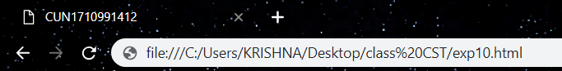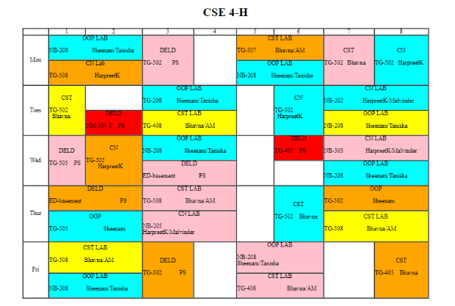

**Experiment - 7**

**Aim** - Create a document with two links to an external document. The first link should lead to the beginning of the external document. The second link should lead to a particular section in the external document.

**Code** -

**<!DOCTYPE html>**

**<html>**

**<head>**

**<title>CUN1710991412</title>**

**</head>**

**<body>**

**<a href="exp1.html#a1" target="main">click here</a> for paragraph 1**

**<br>**

**<a href=”exp2.html#a2” target="main">click here</a> for paragraph 1**

**<br>**

**<a href="https://fb.com" target="main">click here</a> for paragraph 1**

**</body>**

**</html>**

**Output-**

